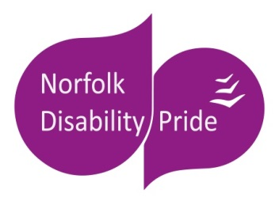
Norfolk Disability Pride 2020
Stallholder Application Form

DP20 takes place on SUNDAY 27th SEPTEMBER 2020 between 10am and 4pm at
The Forum, Millennium Plain, Norwich, Norfolk.
Disability Pride is now in its third year and it is growing.
We want the event to be informative and educational, to raise awareness of disability and the pride we have in our community, while also being interactive, fun and celebratory.

Costs and Sponsorship
There is NO FEE for stalls and activities delivered by charities and voluntary organisations.
The fee for non-charities is
- £100 (if you employ fewer than 100 people)
- £200 (if you employ more than 100 people).
If you or your organisation would like to sponsor the event, even for a small amount, we would love to hear from you.
We also need volunteers to help run the event.
If you can offer any of these please contact disabilitypride@equallives.org.uk

Deadline for applications
All applications to take part in Disability Pride must be received by *
Notifications on stallholder applications will be sent out no later than *
Payments must be received by * or we will reserve the right to offer your space to someone on the waiting list.

Apply
To apply, please return the completed application form either via post or email by the above deadline. Payment does not need to be made until your stall has been confirmed.
Email: disabilitypride@equallives.org.uk
Post: Disability Pride C/O Equal Lives, 15-17 Manor Farm, Fox Road, Framingham Pigot NR14 7PZ
Please include your ??? in your application so we can publicise your attendance in future PR for the event.

Norfolk Disability Pride 2020
Stallholder Application Form

Organisation Name -
Contact Name -
Email -
Phone -

1: Please tick which of the below describes your organisation:
- Charity or voluntary organisation
- Private Business
- Other
- If other, please specify

2: Please tick which of the below would most accurately describe your stall:
- Information only
- Activities and demonstrations
- Workshops or talks
- Other
- If other please specify

3: Do you require indoor or outdoor space for your stall?
(If you have an outdoor stall, you will need to ensure you are prepared for bad weather as relocating inside will not be an option.)
- Indoor
- Outdoor
- Don’t mind
- Both

4: Please tick which of the following apply to you:
- We need a power supply
- We are bringing our own electrical equipment
- We need space for demonstrations or activities
- We need a quiet space to talk to people
- Our stall will be loud
- Other (please specify)

5: What does Disability Pride mean to you? Why do you want to attend? (200 word limit)

6: What will your stall involve? Please give a basic outline of the type of activity you’re planning (200 word limit)

YOUR DATA: We will not share any of the information provided on this form with anyone outside of the organising committee for Norfolk Disability Pride. The information requested here is for the purposes of organising the event only. We will keep the information provided as we hope this will become an annual event and so may be contacting you for future year’s Disability Pride events.

